3D Mobile Animation using Minkowski morph

Nick Baughman
Sungbae Kim
Sonali Batra

ABSTRACT
In this paper, we present a methodology for creating a ‘Mobile Design Studio’. In our design, a user interface is provided for creating a hierarchical mobile structure with mobiles hanging from branches of mobiles. The user can edit the structure, direction of rotation and speed of rotation of individual mobiles. The user can choose predefined 3D shapes, represented by a triangle mesh, to hang on the leaves of the structure. These rotate about the wire on which they are hung and morph to a different shape over time. We also present a methodology and implementation of 'realistic hangings' and 'texture mapping'.
Keywords
Morphing, Minkowski Morph, Mobile, Animation, Algorithm, Centre of Mass, texture mapping, quad

INTRODUCTION
In our Mobile Design Studio, the user is provided an interface for building the structure of the hierarchical mobile. She can add and delete child nodes as per her choice, starting from the root node. She can also control the rotational motion of individual mobiles by changing the direction and speed of rotation. In addition, she can choose the 3D shape to be hung on the leaf nodes. Hanging is implemented 'realistically' i.e. taking into account the body's centre of mass . Clicking on a node using the mouse displays a menu of options representing the actions that can be performed on that node.
The Minkowski Morph method is used to morph the 3D shapes hung to the leaves of the mobile to a different shape over time. In Section 2 of this paper, we describe the Minkowski Morph in detail. In Section 3, we elaborate on our algorithm for morphing one shape to another. In Section 4 ,we briefly discuss the implementation details and data structures used which would be useful to anyone wanting to try a similar exercise in the future. Lastly, In Section 5, we elaborate upon our scheme for realistic hangings followed by texture mapping in Section 6.Lastly, in Section 7, we display some of our results.

THE MINKOWSKI MORPH

For two regions A and B, the Minkowski sum is defined as the region swept by B when its origin wanders all over A. If B is small, then the result is similar to A and vice versa. The Minkowski sum operator combines the geometric characteristics of its its two arguments, hence it is much more suited for morphing than a simple union operator.

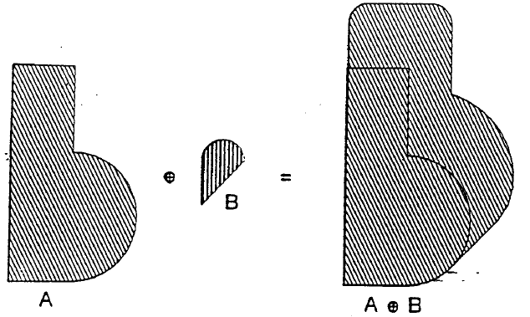
Figure 1. The Minkowski sum combines the shape characteristics of its arguments A and B

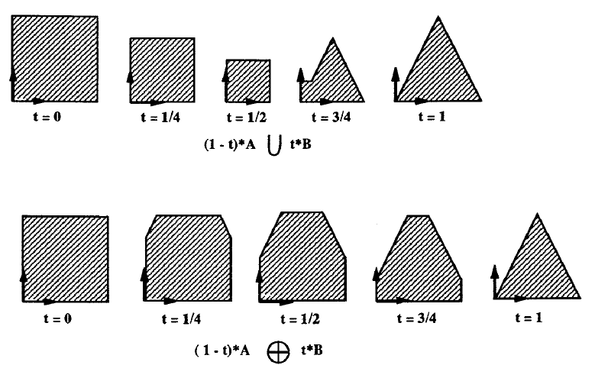

Figure 2. Morphing by Union versus Minkovski sum

3.ALGORITHM FOR MORPHING
Given any two arbitrary polyhedra A and B, the faces of the resultant morph are subsets of the faces produced when we match all vertices to faces, faces to vertices and edges to edges. The conditions for mapping are given below.
A few notations-
T_{E} is the tangent vector to the edge E. It is the unit vector parallel to E.
Given a face F and edge E, the inface normal N_{E,F} to E with respect to F is defined by the unit vector with direction N_{F} x T_{E ,} oriented such that it points towards the interior of the face.
The tentative VF, FE and EE are tested as follows-
1) VF and FE – We check to see if the normal to the face has a negative dot product with all the tangents to a vertex.
2) EE- Let N_{E} define the set of inface normals of all the faces bounded by the edges E_{A} and E_{B.} Also, let N = T_{EA} x T_{EB.} Then we morph only if for all Ni belonging to N_{E} , N. Ni has a constant sign.
Figure 3. 3D Minkowski Morph. Face to vertex- green. Edge to Edge- red, Vertex to face- blue

4.IMPLEMENTATION DETAILS AND DATA STRUCTURES USED-

Basic Structure of Mobile-
The data structure of the mobile is a tree . The Mobile consists of many mobile nodes and each node can have zero to many child nodes. There are three kinds of node, which are thread node, bar node, and custom node. Each one has different features. The thread node is to simulate a thread and should have just one bar or custom node as its child. Bar node simulates bars in mobile and has various thread nodes as its children. Custom node should be the leaf nodes and have mesh models. With the tree structure, it is simple to implement dependent and independent moves of each node, to process commands for each node and to save or load the mobiles in a file. All command are executed in order of depth-first.

Data Structure for Morphing-
In order to implement the minkowski morph by the above algorithm, we need to explore adjacencies in the mesh i.e. The morphing function needs to know which vertices are adjacent to a particular vertex in the triangle mesh, which two faces are incident to a given edge and what is the normal to a given face. We deal with this by using the following data structure. We define a class mesh that has three arrays of type TriangleFace, TriangeVertex and TriangleEdge respectively. Instead of storing actual points in TriangleFace and TriangleEdge, we store indices to the TriangleVertex array. Refer to figure 4. and 5. for details. There is a boolean 'valid' for determining if an entity is within the mesh.

class TriangleVertex {
p3 vert;
int[] adjacencies = new int[6];
boolean valid;
TriangleVertex(p3 v) {
vert = v;
valid = false;
for (int i = 0; i < 6; i++) { adjacencies[i] = 0; }
}
};

Figure 4.

class TriangleFace {
int A, B, C;
v3 faceNormal;
boolean valid;
TriangleFace(int a, int b, int c) {
A = a; B = b; C = c;
valid = false;
faceNormal = new v3(0,0,0);
}

class TriangleEdge {
int A, B;
int tri1, tri2;
boolean visited;
TriangleEdge(int a, int b, int t1, int t2) {
A = a; B = b; tri1 = t1; tri2 = t2;
}
};

Figure 5.

For each vertex, we store an array of indices of vertices that it is adjacent to. For each face, we compute and store its face normal and for each edge, we store the indices of the two faces that are incident to it.
For morphing, in a 2D array,we store the list of point index pairs A and B to interpolate between.We do this to make our program space efficient. The other naïve alternative is to store each resultant triangle separately.

class MorphResult {
TriangleFace[] faces = new TriangleFace[10000]; //list of triangles -> A,B,C are indexes of the list list stored in resultPair
int[][] resultPair = new int[10000][2]; //list of point index pairs A and B to interpolate between
int triCount;
int pairCount;
MorphResult() {
triCount = 0; pairCount = 0;
for(int i=0; i<faces.length;i++) faces[i] = new TriangleFace(0,0,0);
for(int i=0; i<resultPair.length;i++) { resultPair[i] = new int[2]; resultPair[i][0] = 0; resultPair[i][1] = 0; }
}

Figure 6. The result of morphing algorithm stored in resultPair as a list of point index pairs A and B to interpolate between.

5.REALISTIC HANGING-
For realistic hanging, we need to calculate the center of mass of a mesh we load it. For each triangle, we can calculate the volume of polyhedra made by triangle and origin. The sum of each volume is whole volume of a mesh. So center of mass is weighted average of all triangles.

Figure 7. The black dot is the centre of mass of the horse. The figure on the right portrays realistic hanging as opposed to that on the left.

∑Vi/V*(Ti.A+Ti.B+Ti.C)
Vi = volume of each polyhedra made by triangle and origin, V = whole volume, Ti : each triangle, Ti.A, Ti.B, Ti.C : vertices of a triangle
Figure 8. Formula for calculating the centre of mass of a mesh

6. TEXTURE MAPPING-
As a finishing touch, we implemented texture mapping on the nodes. We made quads for each sphere and calculated the texture coordinate for each quad.

Figure 9- Texture Mapping

7. RESULT-
Our resultant integrated code creates an applet in which a Mobile Design Studio is implemented.

Figure 10. Our Mobile Design Studio

8.ACKNOWLEDGMENTS-
The authors would like to thank Dr. Jarek Rossignac for the excellent guidance given for this project

9.REFERENCES-

1)Jarek Rossignac, Anil Kaul, “Solid Interpolating Deformations: Construction and Animation of PIPS”, Computer and Graphics, Vol. 16, No. 1, pp. 107-115, 1992.
2)For centre of mass formula and code-
http://www.melax.com/volint

http://www.melax.com/volint
3)For Texture Mapping-
http://local.wasp.uwa.edu.au/~pbourke/texture_colour/spheremap/
4)CS 6491 Fall 2007 Class Slides
http://www.gvu.gatech.edu/~jarek/courses/6491/

